1. Write the algorithm to find the median of an unsorted array of n elements with the time O (n) in average case. Analyze the complexity (average case) of the algorithm.

Divide input into $\left\lceil n/5\right\rceil$ group of size 5: 0(n) => Find the medians of each group: 0(n) => Find the median of all pivots as medians found: n/5 => Complexity O(n).

1. Optimal substructure property: a problem is said to have optimal substructure if an optimal solution can be constructed efficiently from optimal solutions of its subproblems. This property is used to determine the usefulness of dynamic programming and greedy algorithms for a problem.
2. Divide and Conquer vs. Dynamic Programming:Both techniques split their input into parts, find subsolutions to the parts, and synthesize larger solutions from smaller ones. Divide and Conquer splits its input at prespecified deterministic points (e.g., always in the middle). Dynamic Programming splits its input at every possible split points rather than at pre-specified points. After trying all split points, it determines which split point is optimal.
3. Greedy vs. Dynamic Programming:

* Both techniques are optimization techniques, and both build solutions from a collection of choices of individual elements.The greedy method computes its solution by making its choices in a serial forward fashion, never looking back or revising previous choices.Dynamic programming computes its solution bottom up by synthesizing them from smaller subsolutions, and by trying many possibilities and choices before it arrives at the optimal set of choices.There is no a priori litmus test by which one can tell if the Greedy method will lead to an optimal solution.By contrast, there is a litmus test for Dynamic Programming, called [The Principle of Optimality](http://www.seas.gwu.edu/~ayoussef/cs212/dynamicprog.html#poo)

1. Some terms
2. Greedy method: A greedy algorithm is an [algorithm](http://en.wikipedia.org/wiki/Algorithm) that follows the [problem solving](http://en.wikipedia.org/wiki/Problem_solving) [heuristic](http://en.wikipedia.org/wiki/Heuristic_(computer_science)) of making the locally optimal choice at each stage with the hope of finding a global optimum.
3. Longest common subsequence (LCS) problem: The longest common subsequence (LCS) problem is to find the longest [subsequence](http://en.wikipedia.org/wiki/Subsequence) common to all sequences in a set of sequences.
4. Optimal substructure property: a problem is said to have optimal substructure if an optimal solution can be constructed efficiently from optimal solutions of its subproblems. This property is used to determine the usefulness of dynamic programming and greedy algorithms for a problem.
5. A [spanning tree](http://en.wikipedia.org/wiki/Spanning_tree_(mathematics)) of that graph is a [subgraph](http://en.wikipedia.org/wiki/Glossary_of_graph_theory#Subgraphs) that is a [tree](http://en.wikipedia.org/wiki/Tree_graph) and connects all the [vertices](http://en.wikipedia.org/wiki/Vertex_(graph_theory)) together. A minimum spanning tree (MST) or minimum weight spanning tree is then a spanning tree with weight less than or equal to the weight of every other spanning tree.
6. Shortest Path Problem:
7. Greedy method cannot work on Shortest Path Problem by given a counter example.

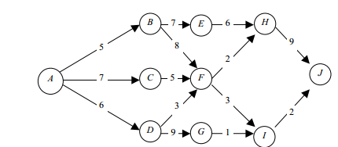

From A B E, H J. The total distance for choosing this path is 27.

Greedy algorithm is an easy and direct way to find out a solution, but it doesn’t promise the solution is necessarily optimal. the shortest distance is actually 14 in the above case. The difference is there because greedy algorithm does not consider the consequence when choosing the best way to go.

b. We know A-D-F-I-J is the shortest way. from A to F, it is “A-D-F”. Solving the big problem by dividing it into simpler subproblem and combine the subsolution to make general solution(optimal substructure property.

c. We don’t use same strategy (dynamic programming) to solve longest Path Problem, which tries to find a longest simple path between two nodes in a graph? Why or Why not?

- The longest path problem, on the other hand, does not satisfy the Principle of Optimality. Take for example the undirected graph G of nodes a, b, c, d, and e, and edges (a, b) (b, c) (c, d) (d, e) and (e, a). That is, G is a ring. The longest (noncyclic) path from a to d to a, b, c, d. The sub-path from b to c on that path is simply the edge b, c. But that is not the longest path from b to c. Rather, b, a, e, d, c is the longest path. Thus, the subpath on a longest path is not necessarily a longest path.

1. Upper bound, lower bound, supremum





Supremum is least upper bound.

1. Simple path is a path with no cycle at one point.

Simple cycle is a closed walk with no repetitions of vertices and edges allowed, other than the repetition of the starting and ending vertex.

1. Heap and binary Tree: a binary heap guarantees that the nodes on higher level are larger than the nodes on lower level. Binary Tree guarantees that the nodes on right are larger than the nodes on left.

A randomized algorithm is an [algorithm](http://en.wikipedia.org/wiki/Algorithm) which employs a degree of [randomness](http://en.wikipedia.org/wiki/Randomness) as part of its logic. The algorithm typically uses[uniformly random](http://en.wikipedia.org/wiki/Uniform_distribution_(discrete)) bits as an auxiliary input to guide its behavior, in the hope of achieving good performance in the "average case" over all possible choices of random bits.  Quicksort is a divide and conquer algorithm.DMP:Characterize the structure of an optimal solution. Recursively define the value of an optimal solution. Compute the value of an optimal solution in a bottom up fashion. Construct an optimal solution from computed information.

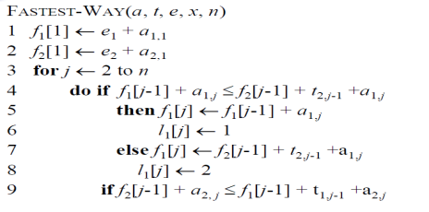

1. The master method

Let a >= 1and b > 1 be constants, let f (n) be a function, and T(n) be defined on the nonnegative integers by the recurrence T(n) = aT(n / b) + f (n ) where we interpret n / b mean either $\left\lfloor n/b\right\rfloor$ or

+ If $f\left(n\right)=O(n^{\log_{b}{a-ε}})$ for some constant ɛ > 0, then

+ If $f\left(n\right)=Θ(n^{\log_{b}{a}})$ then

+ If $f\left(n\right)=O(n^{\log_{b}{a+ε}})$ for some constant ɛ > 0 and if $af\left(n/b\right)=cf(n)$ for some constant c < 1 and all sufficiently large n, then $T\left(n\right)= Θ(f(n))$.